OBJECT ORIENTED PROGRAMMING USING JAVA

NAME : P.R.DHANVIN

DEPT & SEC : CSE & B

ROLL NO : 230701071

WEEK : 9

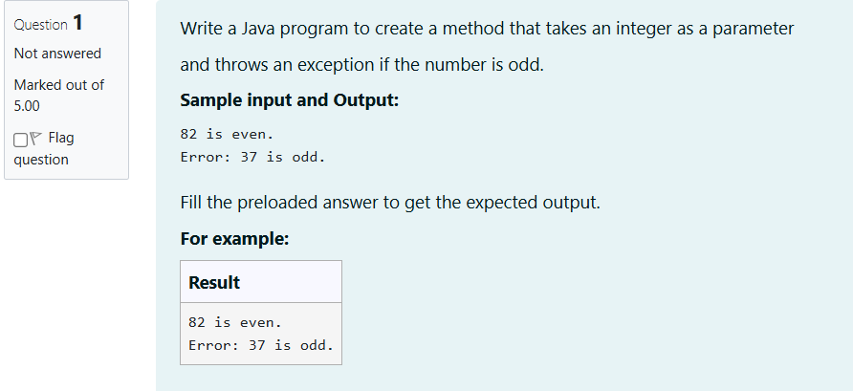

import java.util.Scanner;

public class ExceptionHandlingExample {

public static void main(String[] args) {

Scanner scanner = new Scanner(System.in);

try {

int size = scanner.nextInt();

int[] arr = new int[size];

for (int i = 0; i < size; i++) {

arr[i] = scanner.nextInt();

}

int result = arr[0] / arr[1];

System.out.println("Accessing out-of-bounds element: " + arr[3]);

} catch (ArithmeticException e) {

System.out.println("java.lang.ArithmeticException: " + e.getMessage());

} catch (ArrayIndexOutOfBoundsException e) {

System.out.println("java.lang.ArrayIndexOutOfBoundsException: " + e.getMessage());

} finally {

System.out.println("I am always executed");

}

}

}

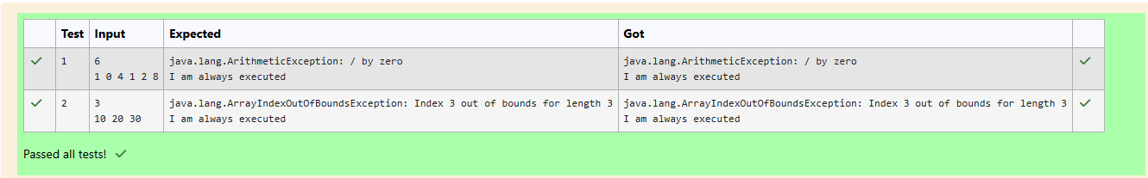

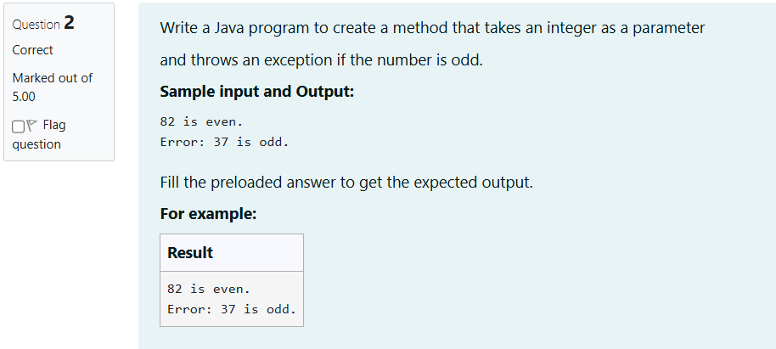

class prog {

public static void main(String[] args) {

int n = 82;

trynumber(n);

n = 37;

trynumber(n);

}

public static void trynumber(int n) {

try {

checkEvenNumber(n);

System.out.println(n + " is even.");

} catch (IllegalArgumentException e) {

System.out.println("Error: " + e.getMessage());

}

}

public static void checkEvenNumber(int number) {

if (number % 2 != 0) {

throw new IllegalArgumentException(number + " is odd.");

}

}

}

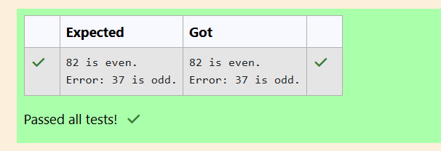

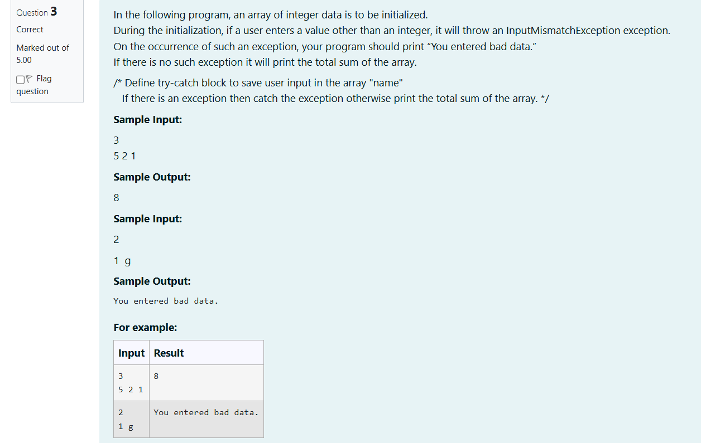

import java.util.Scanner;

import java.util.InputMismatchException;

public class ArraySumDemo {

public static void main(String[] args) {

Scanner scanner = new Scanner(System.in);

int size = scanner.nextInt();

int[] array = new int[size];

try {

for (int i = 0; i < size; i++) {

array[i] = scanner.nextInt();

}

int sum = 0;

for (int num : array) {

sum += num;

}

System.out.println(sum);

} catch (InputMismatchException e) {

System.out.println("You entered bad data.");

} finally {

scanner.close();

}

}

}

